SIMPOD Connect Software

Installation, Setup & Calendar Creation Guide

For use with Simmonsigns Smart PULSA Revision 2

**Simple step-by-step guide**

**Scope**

There are 3 different versions of the SIMPOD Connect Software.

This guide refers to the SIMPOD Connect Software for use with Smart PULSA Revision 2.

You can identify a revision 2 SMART PULSA by the stock code : on the product silver label PULSA/SMRT/R2 and the badge on the front of the product with silver back as shown.

**Download & Installation**

The SIMPOD Connect Software (New 2023 version) can be downloaded from the Simmonsigns website, navigate to : -

<https://simmonsigns.co.uk/road-safety-solutions/wig-wag-lights/smart-pulsa/>

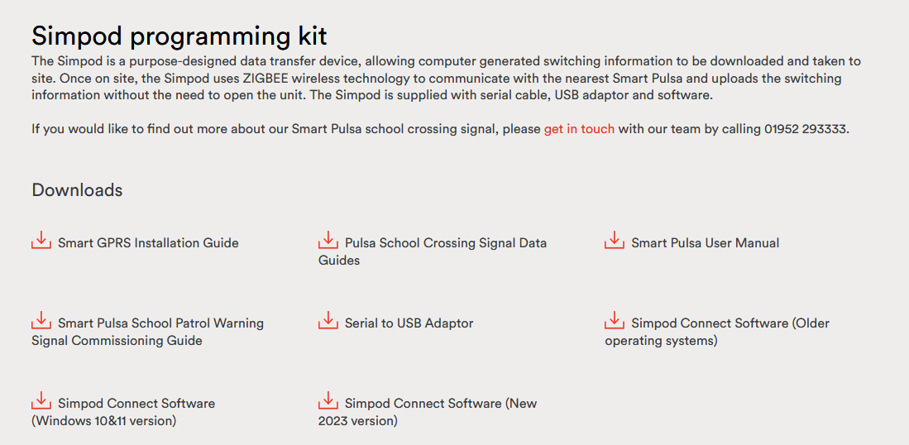

Click the icon highlighted above to download the SIMPOD Connect Software (App)

After download, click the icon highlighted below to see the files then, extract all files

Now double click the icon highlighted below and then click install the SIMPOD Connect Software (App)

**Organising a Calendar**

By clicking on the appropriate, fields you can input times for on/off.

It is possible to have 8 patterns, which can be used during the calendar creation process. Up to 5 on/off periods can be selected per switching pattern (per day).

Select the Calendar tab, ready to set up a calendar :-

Days can be allocated to individual patterns by selecting them individually or you can use the dropdown options, select days that have preset options such as weekends or weekdays to speed up the process.

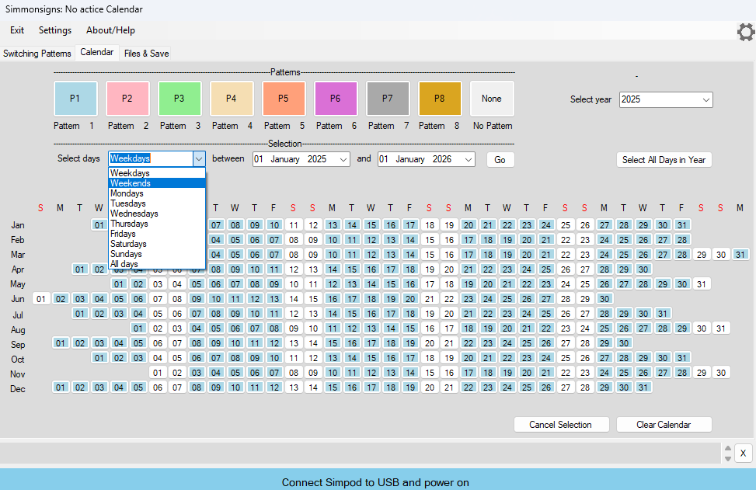

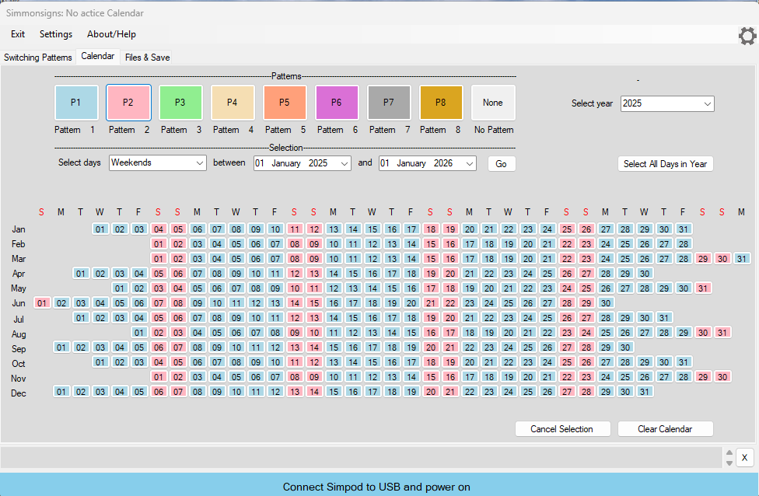

Once the calendar has been created the process of saving it can be started by selecting the “File and save” tab, which presents you with the following options.

Give the calendar a name and select save (select location to be saved).

**Deploying the calendar to the SIMPOD/R2**

Connect the SIMPOD (Shown right) to the computer using the USB A to Mini-B lead.

Sometimes during first use it may be necessary to check that the SIMPOD has correctly been allocated a COM port.

This is indicated by the Blue bar at the bottom turning Green when the SIMPOD is connected and turned on by pressing the centre button.

.

If it has not connected it will be necessary to do this Manually.

Select the cog icon at the top right of the app window.

This will reveal 3 additional tabs “Exit”

“Settings”

“About/ Help”

Select the “Settings” tab. And then the “SIMPOD Comms” This opens-up the following pop-up window. It is possible to select alternative COM ports using this part of the app by selecting “Change COM Port”

If it is unclear which COM port to select or no options are offered it will be necessary to go into the windows “Device Manager” and establish the correct COM number.

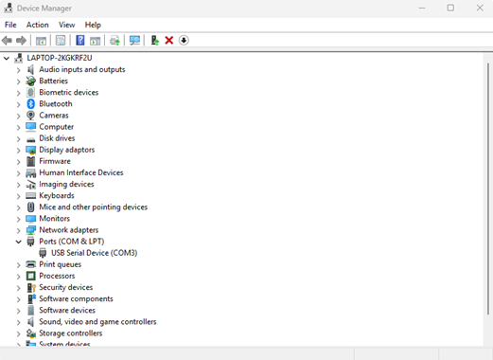

Once the correct COM port has been selected the bottom Bar will turn green. Press Done. The SIMPOD is ready to receive the calendar.

Once you have connected the SIMPOD, select which calendar you wish to send to the SIMPOD using the “Load from File” drop down box.

Once the calendar has been selected. Then select “send” This will produce the following. The SIMPOD will send acknowledgment back to the app if the deployment was successful.

**Troubleshooting**

Reasons for failures when deploying calendars to the SIMPOD :-

If the SIMPOD will not receive a new calendar check that it is still connected to the computer. The SIMPOD times out when it has been inactive. This is normal operation and the SIMPOD simply needs to be turned back on.

If the SIMPOD has reached its max calendar storage capacity it will not allow additional calendars to be stored until existing calendars have been deleted. The following screen will be displayed with a Red bar along the bottom:-

